**Description**

The game I have made has 3 levels. The first level is from Mario Bros. and the other two are linked. One of the other levels is a level editor, and the other allows you to play that custom level, the level editor tile and enemy options are inspired by the first Super Mario Bros, it uses sprites and sounds from that game. There is also a main menu inspired by the first Super Mario Bros. It has a modified logo and I’ve added my name. I tried to replicate the main menu of Super Mario Bros. 1 using the sprite tiles from Level 2.

**Controls**

Arrow Keys Movement

Escape Pause

Mouse & Left Click Use pause menus

Left Click (On Select Sprites UI) Select Sprite (*Level editor*)

Left Click (On game level canvas) Draw Sprite (*Level editor*)

Right Click (On game level canvas) Erase Sprite (*Level editor*)

Middle click & drag Pan camera (*Level editor*)

**Screenshots**

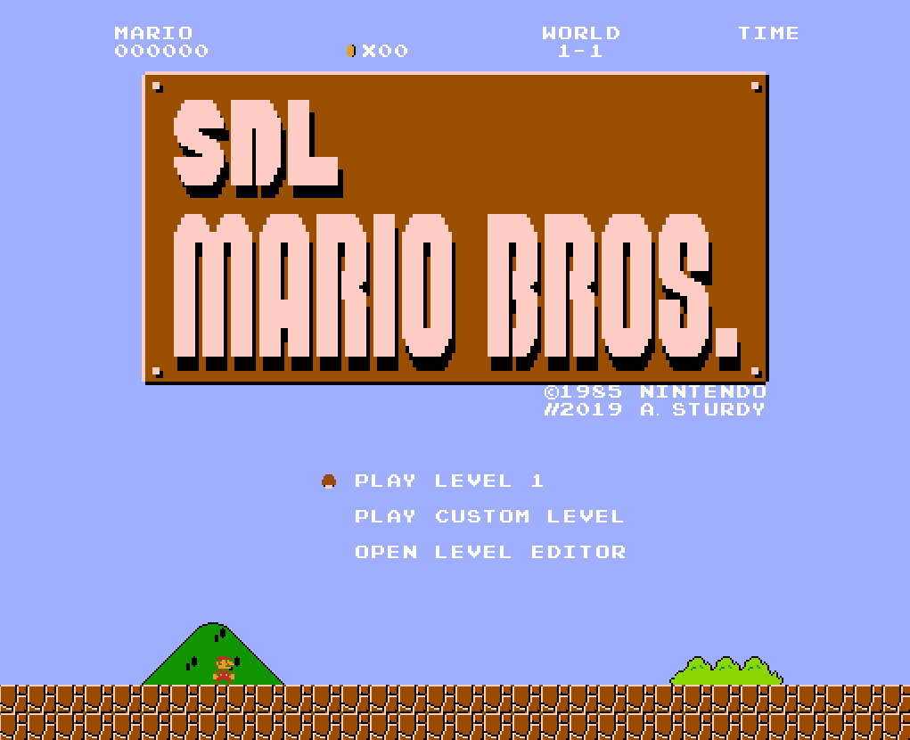

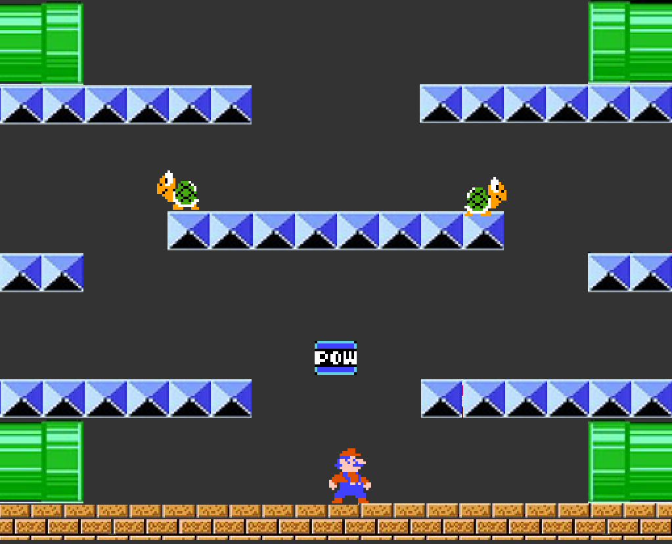

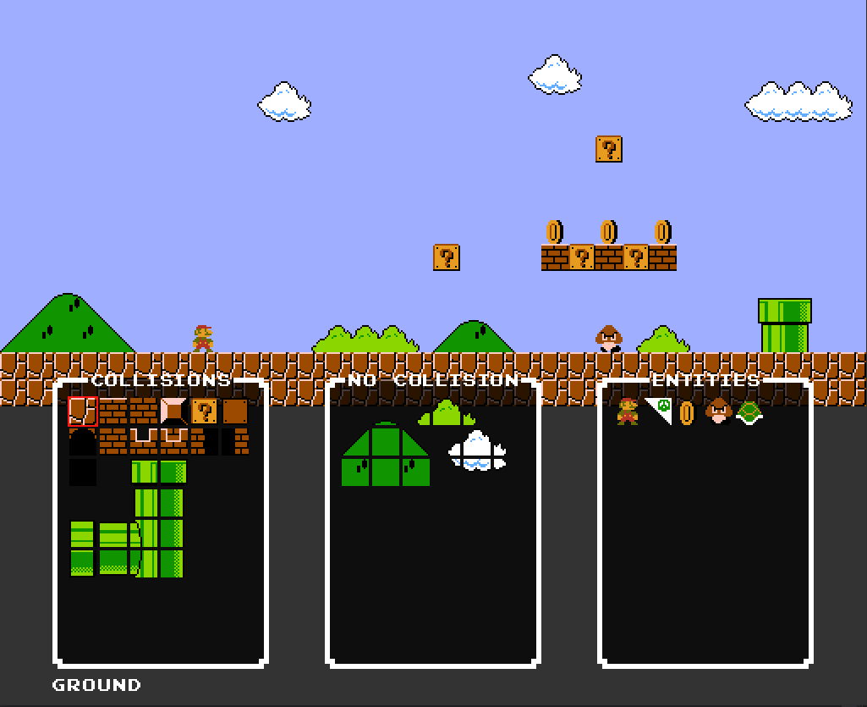

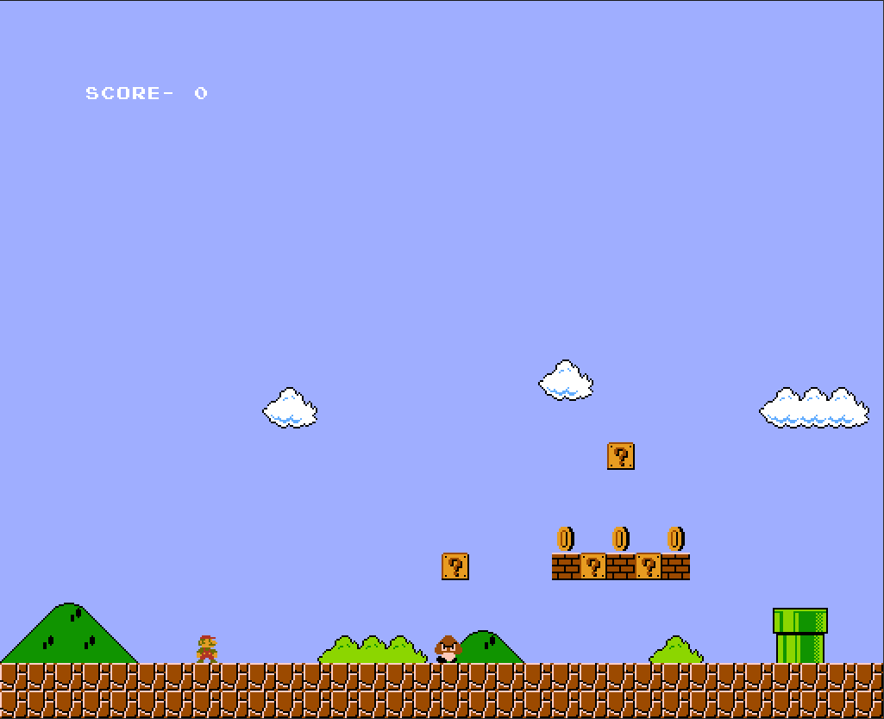

**Test Plan**